-: Online examination system using java :-

Name : Sanskruti Kanoje
Reg. no.: 25BAI11315
Subject : Introduction to Java
Faculty : Rizwan Ur Rahman
Date : 18/09/2026

Introduction :-
The Online Examination System is a Java-based application designed to conduct examinations digitally in a simple, efficient, and organized manner. The system allows students to log in, select an examination, answer multiple-choice questions within a specified time, and submit their answers online. After submission, the system automatically evaluates the answers and generates the student's result.
The system also provides an Admin module through which administrators can add, update, or delete questions and manage examination results. Features such as a countdown timer, automatic submission, question navigation, and result calculation make the examination process faster and more convenient.
The project is developed using Java, with concepts such as Object-Oriented Programming, Collections, Exception Handling, File Handling, and JDBC. A database such as MySQL can be used to store student information, questions, and examination results. The main objective of this project is to provide a reliable digital platform that reduces manual work and makes the examination and evaluation process more efficient.

Problem Statement :-
Traditional examination systems require considerable time, paperwork, and manual effort for conducting exams and evaluating answer sheets. Managing large numbers of students, preparing question papers, checking answers, calculating marks, and maintaining results can be time-consuming and may lead to human errors.
Therefore, there is a need for a computer-based Online Examination System that can conduct examinations in an organized and efficient manner. The proposed system will allow students to attend exams online, answer questions within a fixed time, and receive automatically calculated results. It will also provide administrators with facilities to manage questions, exams, student details, and results.
The system aims to reduce manual work, save time, improve accuracy, and provide a convenient platform for conducting and managing examinations.

Functional Requirements :-
The Online Examination System should provide the following functionalities:
- Student Registration and Login
  - Students can create an account using their required details.
  - Registered students can log in using their username and password.
- Admin Login
  - The administrator can securely log in to the system.
  - Admin can manage examinations, questions, students, and results.
- Exam Selection
  - Students can view the available examinations.
  - Students can select the required subject or examination.
- Question Management
  - Admin can add new questions and multiple-choice options.
  - Admin can update or delete existing questions.
  - Admin can specify the correct answer and marks for each question.
- Online Examination
  - Students can view questions and select their answers.
  - Students can move between questions using Next and Previous options.
  - The system should record the selected answers.
- Timer Management
  - The system should display a countdown timer during the examination.
  - The exam should be automatically submitted when the allotted time expires.
- Automatic Evaluation
  - The system should compare the student's answers with the correct answers.
  - Marks should be calculated automatically after submission.
- Result Generation
  - The system should display the total marks, correct answers, incorrect answers, and percentage.
  - Students should be able to view their examination results.
- Result Management
  - Admin can view and manage the results of students.
  - Results can be stored for future reference.
- Data Storage
- Student details, questions, answers, examination information, and results should be stored securely in the system/database.

Non-Functional Requirements :-
The Online Examination System should satisfy the following non-functional requirements:
- Performance
  - The system should respond quickly to user actions such as login, question navigation, and result generation.
  - Results should be generated within a short time after exam submission.
- Security
  - Student and admin login credentials should be protected.
  - Only authorized administrators should be allowed to manage questions and results.
  - Student examination data should not be accessible to unauthorized users.
- Reliability
  - The system should operate correctly without frequent failures.
  - Answers selected by students should be stored accurately during the examination.
- Usability
  - The interface should be simple and easy to understand.
  - Students should be able to navigate through questions without difficulty.
- Scalability
  - The system should be capable of handling an increasing number of students, questions, and examinations.

- Maintainability
  - The Java code should be organized into separate modules and classes.
  - Future changes and additional features should be easy to implement.
- Availability
  - The system should be available whenever an examination is scheduled.
  - The examination should continue smoothly throughout the specified duration.
- Accuracy
  - The system should evaluate answers and calculate marks correctly.
  - The generated results should accurately represent the student's performance.
- Compatibility
  - The application should work properly on systems that support the required Java version and database software.
- Data Integrity
- Student information, questions, answers, and results should remain consistent and should not be accidentally modified or lost.

System Architecture :-
The Online Examination System follows a three-tier architecture consisting of the Presentation Layer, Application Layer, and Database Layer. This architecture separates the user interface, application logic, and data storage, making the system easier to develop, maintain, and modify.

1. Presentation Layer
This layer provides the user interface of the system. It allows students and administrators to interact with the application.
- Student Login and Registration
- Admin Login
- Exam Selection
- Question Display
- Answer Selection
- Timer Display
- Result Display
The interface can be developed using Java Swing or JavaFX.

2. Application Layer
This layer contains the main business logic of the application. It processes user requests and controls the examination process.
- User authentication
- Exam management
- Question and answer processing
- Timer management
- Automatic evaluation
- Marks and percentage calculation
- Result generation
- Admin operations
The application logic is implemented using Java and Object-Oriented Programming concepts.

3. Database Layer
This layer is responsible for storing and retrieving system data. MySQL can be used as the database, with JDBC providing connectivity between Java and MySQL.
The database can store:
- Student details
- Admin details
- Examination details
- Questions and options
- Correct answers
- Student responses
- Examination results

System Flow
Student/Admin → Java GUI → Application Logic → JDBC → MySQL Database
For a student, the flow is:
Login → Select Exam → Start Exam → Answer Questions → Submit/Time Expires → Automatic Evaluation → View Result

For an administrator, the flow is:
Admin Login → Manage Exams → Manage Questions → Manage Students → View Results
This architecture provides a structured approach to developing the Online Examination System and allows each layer to be modified independently without significantly affecting the other layers.

Design Diagrams :-

1. Use Case Diagram
The Use Case Diagram shows the interaction between the Student, Admin, and Online Examination System.
Students can register, log in, select exams, answer questions, submit exams, and view results.
The Admin can manage students, exams, questions, and results.
It gives a clear overview of the system's major functions and users. 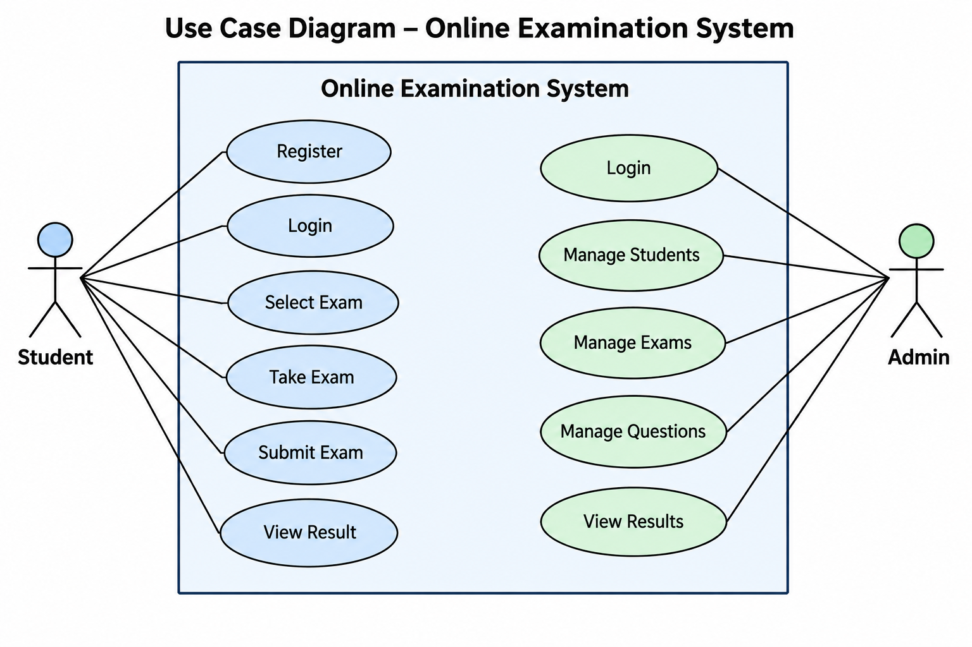

2. Workflow Diagram
The Workflow Diagram represents the step-by-step flow of the examination process.
The student first logs in and selects an exam before answering the questions.
After submission or when the timer expires, the system evaluates the answers automatically.
Finally, the result is calculated and displayed to the student.
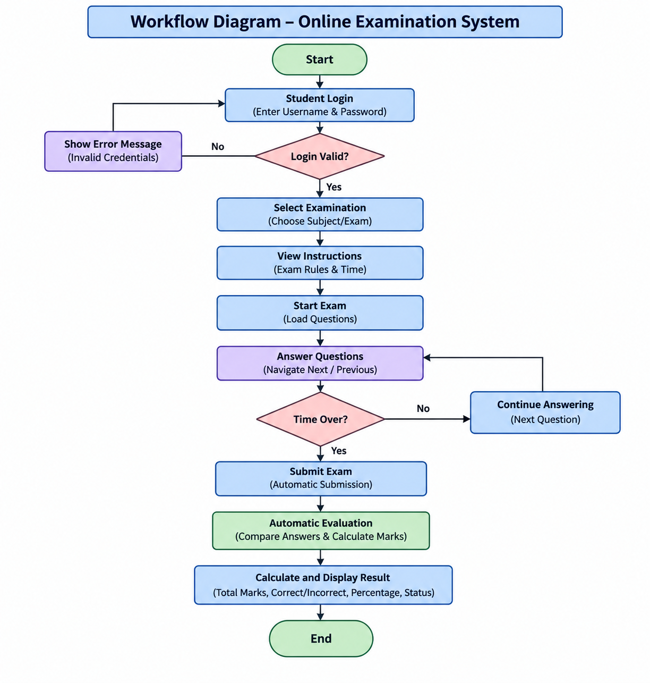

3. Sequence Diagram
The Sequence Diagram shows the order of communication between the Student, System, and Database.
The student sends login and exam requests to the system.
The system retrieves questions, records answers, and sends the responses for evaluation.
After evaluation, the system stores the result and displays it to the student.
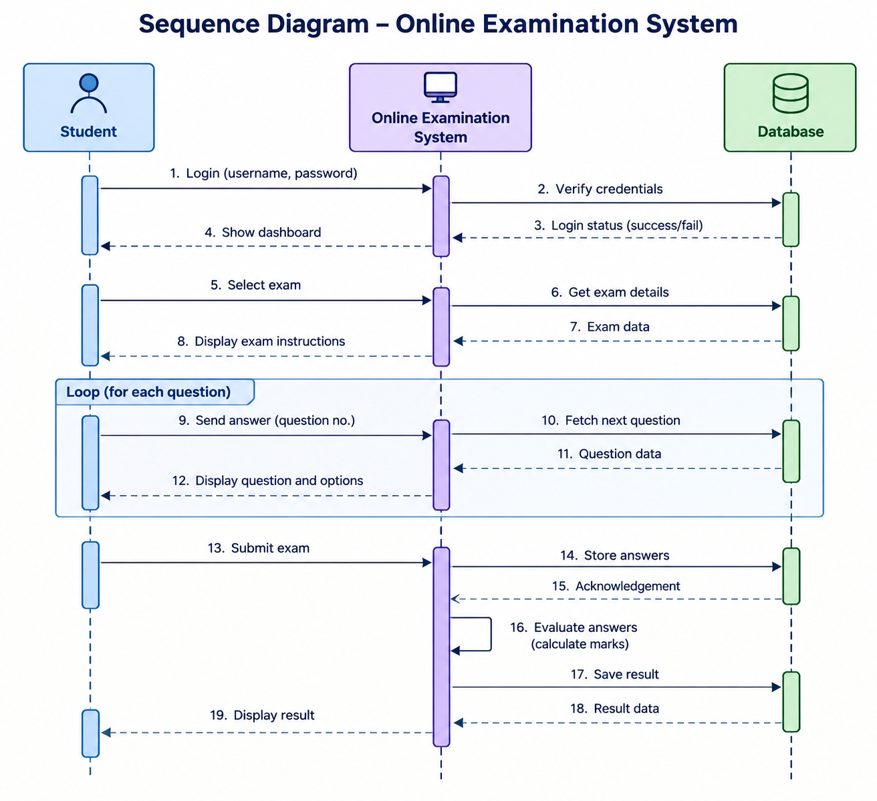

4. Class/Component Diagram
The Class Diagram represents the major classes and their relationships in the Java application.
Important classes include Student, Admin, Exam, Question, Result, and Database.
Each class contains relevant attributes and methods required for its operation. It demonstrates the use of Object-Oriented Programming concepts in the project.
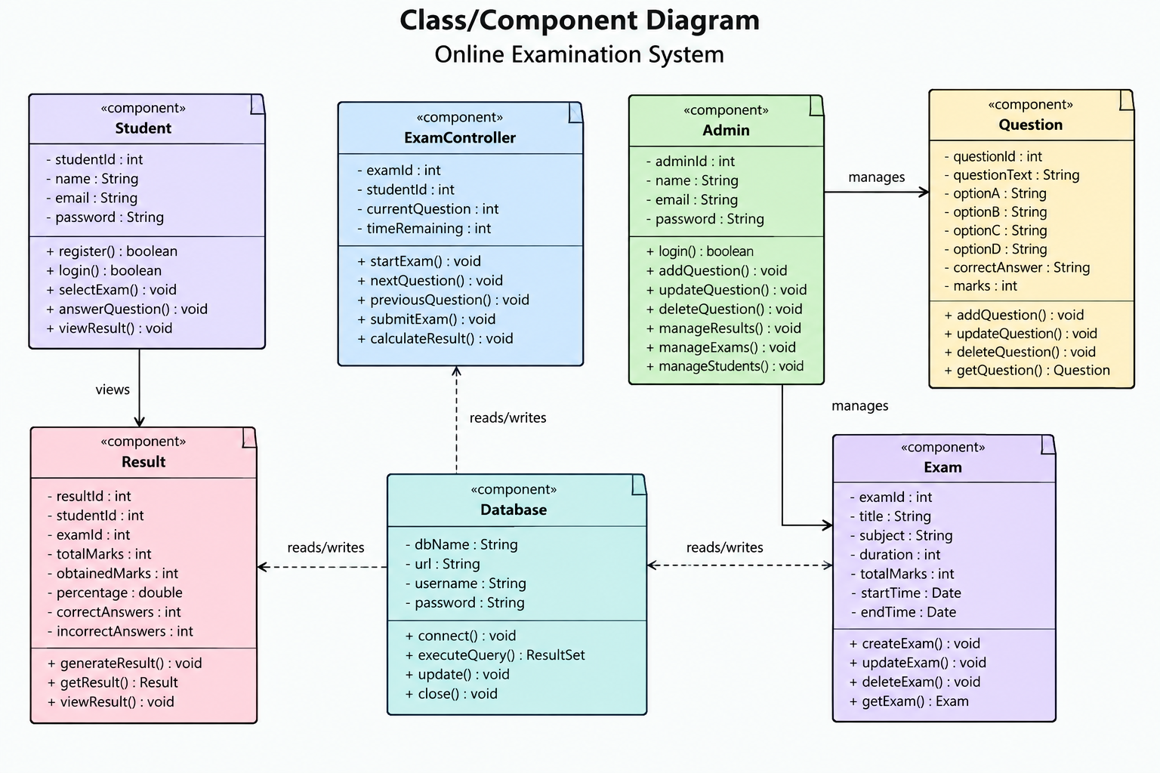

5. ER Diagram
The ER Diagram represents how data is organized and related in the database.
The main entities include Student, Exam, Question, Answer, and Result.
Relationships are used to connect students with exams and their examination results. This diagram provides a logical structure for implementing the MySQL database.
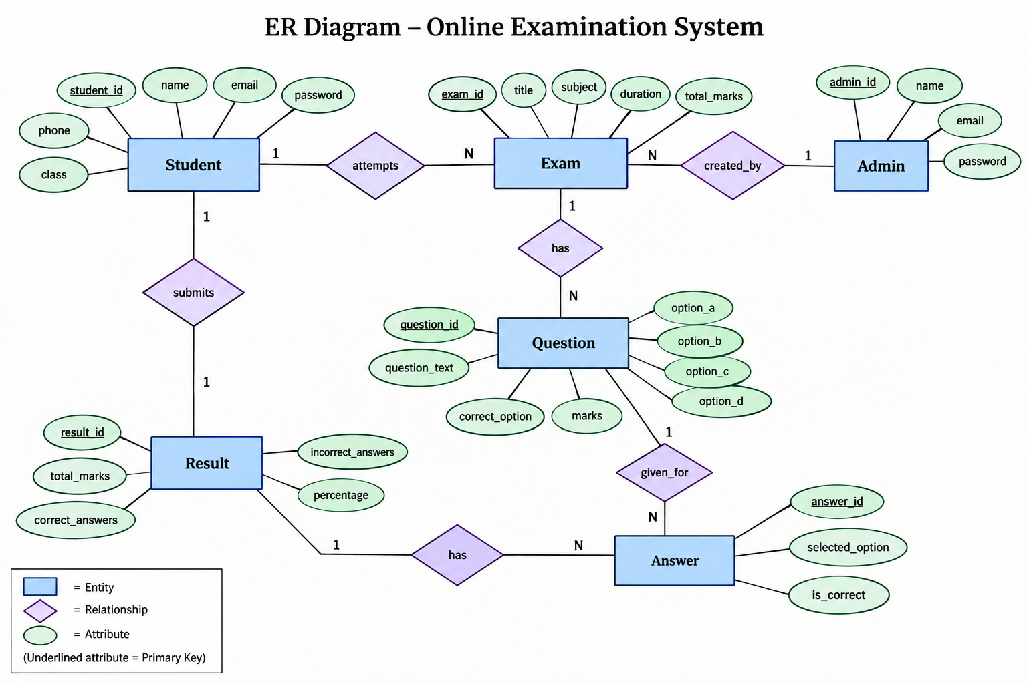

Design Decisions & Rationale :-
The following design decisions were made to make the Online Examination System simple, reliable, secure, and easy to maintain.
- Java as the Main Programming Language
Java was selected because it supports Object-Oriented Programming and provides features such as exception handling, collections, file handling, and database connectivity. It is also suitable for developing desktop-based applications.
2. Three-Tier Architecture
The system is divided into the Presentation Layer, Application Layer, and Database Layer. This separation makes the application easier to understand, test, maintain, and modify.
3. Java Swing for User Interface
Java Swing can be used to create a simple graphical interface for students and administrators. It provides components such as buttons, text fields, labels, and panels required for the examination system.
4. MySQL for Data Storage
MySQL is used to store student details, examination information, questions, answers, and results. This provides organized and persistent storage of important data.
5. JDBC for Database Connectivity
JDBC is selected to establish communication between the Java application and MySQL database. It allows the application to insert, retrieve, update, and delete data.
6. Object-Oriented Design
Separate classes such as Student, Admin, Exam, Question, Answer, and Result are used to represent different components of the system. This improves code reusability and makes the system easier to maintain.
7. Automatic Evaluation
The system automatically compares submitted answers with the correct answers and calculates marks. This reduces manual calculation and provides faster results.
8. Timer-Based Examination
A countdown timer is included to provide a fixed examination duration. When the time expires, the system automatically submits the examination.
9. Role-Based Access
Separate functionalities are provided for Students and Admins. Students can take examinations and view results, while Admins can manage questions, exams, students, and results.
10. Simple and User-Friendly Interface
The interface is designed to be straightforward so that students can focus on answering questions without unnecessary complexity. Clear buttons and navigation options are provided for common operations.

Implementation Details :-
The Online Examination System is implemented using Java and follows Object-Oriented Programming principles. The application is divided into different modules to handle student activities, administrator operations, examination management, evaluation, and result generation.

1. User Authentication : The system provides separate login functionality for students and administrators. User credentials are verified before allowing access to the respective modules.

2. Student Module : The Student module allows students to register, log in, select an available examination, view questions, submit answers, and view their results.

3. Admin Module : The Admin module allows the administrator to add, update, and delete examination questions. The administrator can also manage examinations and view student results.

4. Examination Module : The examination module displays MCQ questions with multiple options. Students can select their answers and navigate between questions during the examination.

5. Timer Module : A countdown timer is implemented using Java's timing/threading features. The timer tracks the examination duration and automatically submits the examination when the allotted time is over.

6. Evaluation Module : After submission, the system compares the student's selected answers with the correct answers stored in the system. Marks are calculated based on the number of correct answers.

7. Result Module : The Result module calculates and displays the student's total marks, percentage, number of correct and incorrect answers, and pass/fail status. Results can also be stored for future reference.

8. Database Implementation : MySQL can be used to store student details, admin details, exams, questions, answers, and results. JDBC (Java Database Connectivity) is used to connect the Java application with the database and perform database operations.

9. Exception Handling : Java exception handling is used to handle errors such as invalid login details, empty fields, invalid input, database connection failures, and other runtime errors.

10. Technologies Used :
- Programming Language: Java
- GUI: Java Swing
- Database: MySQL
- Database Connectivity: JDBC
- IDE: IntelliJ IDEA / Eclipse / NetBeans
- Concepts: OOP, Collections, Exception Handling, Multithreading, and Database Management

Code :-
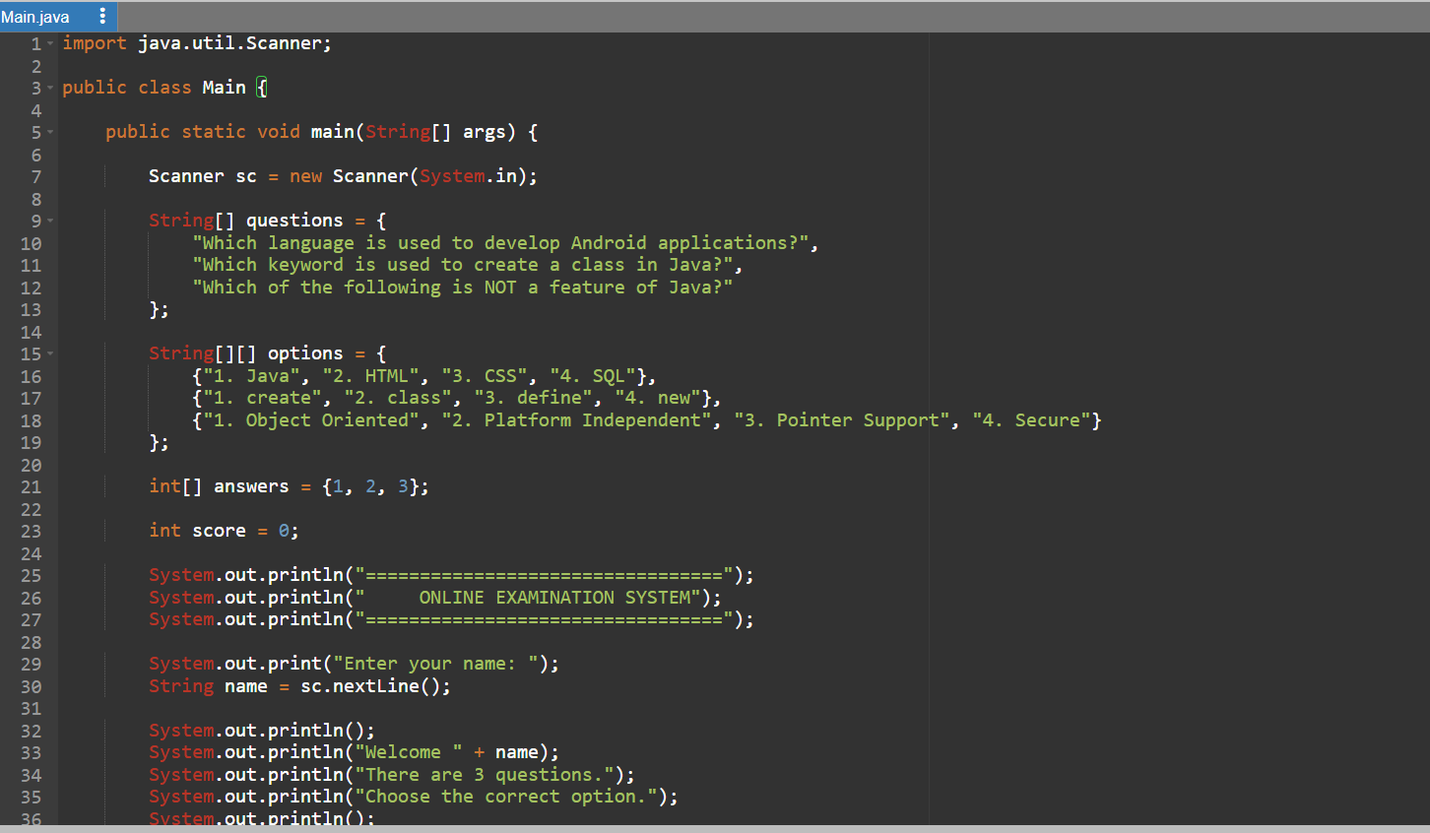
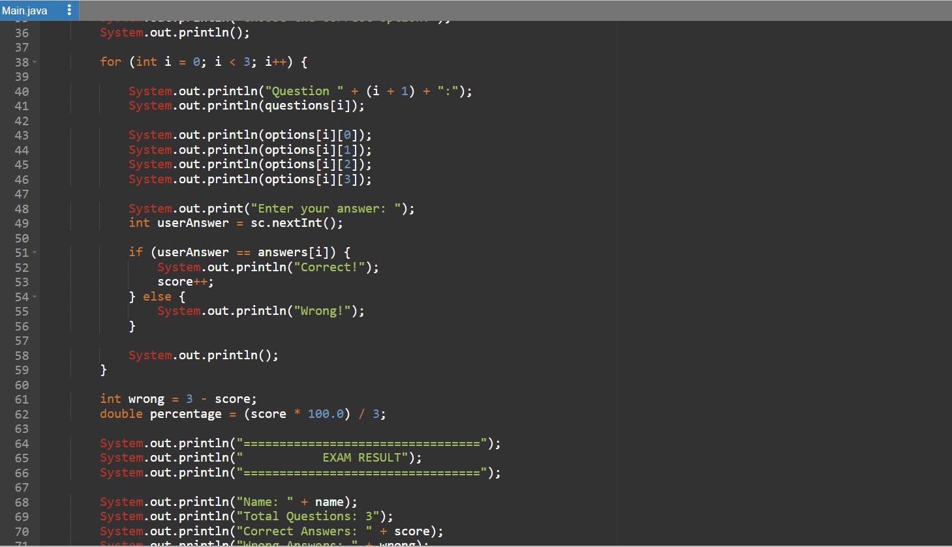
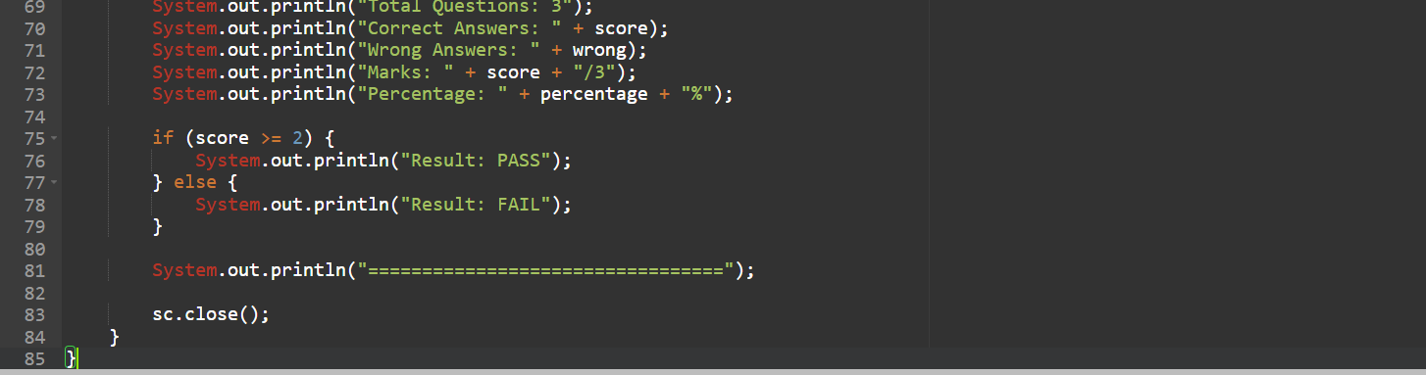

Output :-
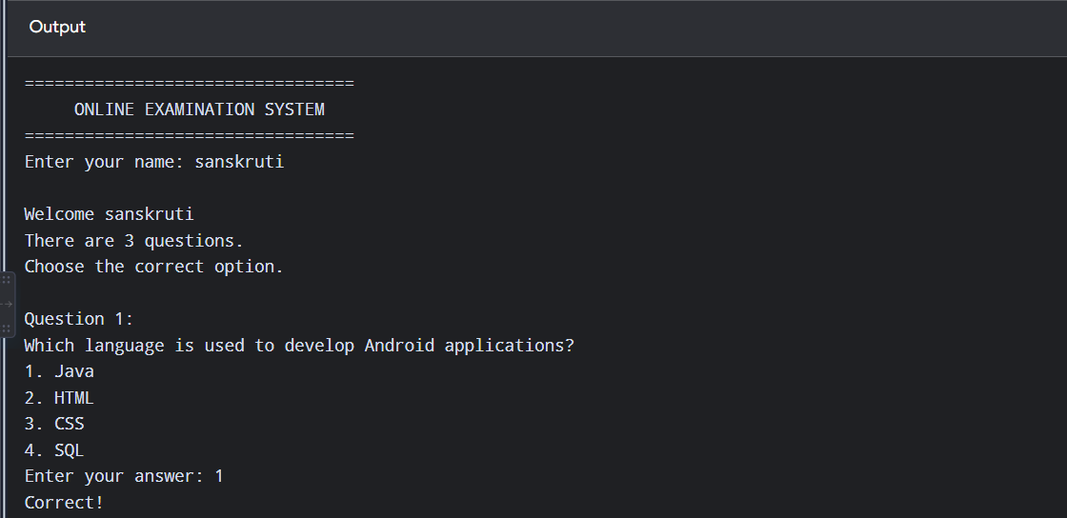
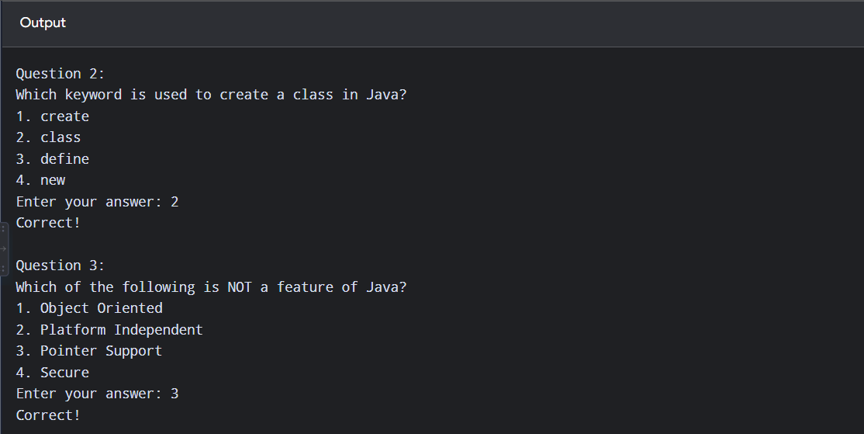
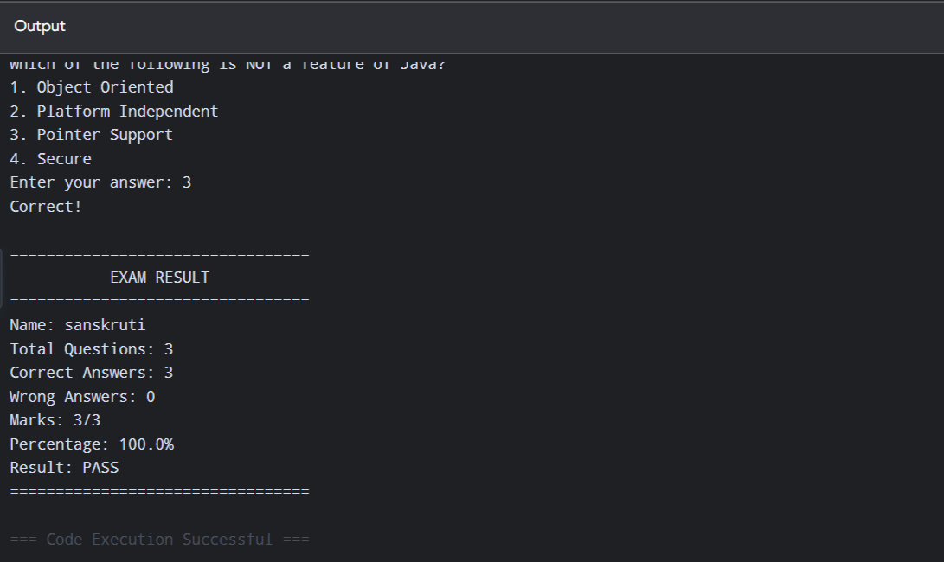

Testing Approach :-
Testing is performed to ensure that the Online Examination System works correctly and produces accurate results. Different inputs and user actions are checked to identify and correct errors in the system.
- Functional Testing
Each feature such as login, question display, answer selection, exam submission, and result calculation is tested to verify that it works as expected.
- Input Testing
Different inputs, including correct and incorrect answers, are provided to check whether the system handles them properly.
- Result Testing
The marks, percentage, correct answers, and wrong answers are checked manually against the expected results to ensure accurate evaluation.
- Error Testing
Invalid or unexpected inputs are tested to ensure that the system does not crash and handles errors properly.
- User Interface Testing
The input prompts, questions, options, and result display are checked to ensure that they are clear and easy to understand.
- System Testing
The complete examination process is tested from start to finish, beginning with entering the student's name and ending with displaying the final result.

Challenges Faced :-
During the development of the Online Examination System, several challenges were faced while designing and implementing the project.
- Handling User Input
Taking answers from the user and ensuring that the entered option is processed correctly was one of the basic challenges.
- Question and Answer Management
Managing multiple questions, options, and correct answers in an organized way required proper use of arrays and loops.
- Result Calculation
Calculating the number of correct and incorrect answers, marks, and percentage accurately required careful implementation of the evaluation logic.
- Error Handling
The system needed to handle invalid inputs and unexpected situations without stopping the program.
- Program Structure
Organizing the Java code into clear and understandable sections was important to make the program easier to read, test, and modify.
- Testing and Debugging
Testing different combinations of answers helped identify programming errors and verify that the final results were generated correctly.

Learnings & Key Takeaways :-
Working on the Online Examination System helped in understanding how Java programming concepts can be applied to develop a practical application.
- Java Programming : Improved understanding of Java syntax, variables, arrays, loops, conditional statements, and methods.
- Object-Oriented Programming : Learned how classes, objects, encapsulation, inheritance, and polymorphism can be used to organize a project.
- Problem Solving : Developed logical thinking by creating the question-answer system, checking answers, and calculating results.
- Exception Handling : Learned how to handle invalid inputs and runtime errors so that the program can work smoothly.
- Data Management : Understood how student information, questions, answers, and results can be organized and managed within an application.
- Testing and Debugging : Learned the importance of testing different inputs and correcting errors before finalizing the project.
- Project Development : Gained experience in planning a project, designing diagrams, writing code, testing the application, and documenting the final work.
- Practical Application of Concepts : Understood how theoretical Java concepts can be combined to create a useful real-world application such as an online examination system.

Future Enhancements :-
The Online Examination System can be further improved by adding more advanced features in the future.
- Online Database : A MySQL or cloud database can be added to store student details, questions, answers, and results permanently.
- User-Friendly GUI : The current console-based system can be upgraded to a graphical interface using Java Swing or JavaFX.
- Timer Feature : A countdown timer can be added to limit the examination duration and automatically submit the exam when time expires.
- Random Questions : Questions can be selected randomly from a larger question bank so that every student receives a different set of questions.
- Multiple Subjects : The system can be expanded to support different subjects and examinations.
- Detailed Performance Report : Students can receive detailed reports showing their marks, percentage, correct answers, incorrect answers, and overall performance.
- Secure Login System : Password encryption and improved authentication can be implemented to protect student and administrator accounts.
- Web-Based Application : The system can be converted into a web application so that students can access examinations from computers or mobile devices through a browser.
- Result History : Students can view their previous examination results and track their academic performance over time.
- Automatic Backup : Automatic backup of examination data can be introduced to prevent loss of important student and result information.

References :-
- Herbert Schildt, Java: The Complete Reference, McGraw Hill Education.
- Cay S. Horstmann, Core Java: Fundamentals, Pearson Education.
- Oracle Java Documentation, Java Platform Documentation.
- Oracle, Java Tutorials – Learning the Java Language.
- MySQL Documentation, MySQL Reference Manual.
- GeeksforGeeks, Java Programming and Object-Oriented Programming Concepts.
- TutorialsPoint, Java Programming Tutorial.
- W3Schools, Java Tutorial and Examples.

THANK
YOU

